 | SR UNIVERSITY  Campus Warangal
 | Program: II - B. Tech (CS& AI) Batch:
Name:A . MADHUGNA
Reg. No:2503A52423
 | Department: Computer Science and AI Semester: I
 | AI Assisted Coding-Assignment Date: 22/09/2026

1.Question
Q1 – AI-Assisted Bubble Sort Analysis
Problem / Starter Code:
numbers = [64, 34, 25, 12, 22, 11, 90]
# TODO:
# Implement Bubble Sort in ascending order.
# Count comparisons and swaps.
# Display the sorted list.
Student Tasks:
• Implement Bubble Sort.
• Use AI to explain one complete pass of Bubble Sort.
• Count comparisons and swaps.
• Test at least three input lists.
• Ask AI about an early-exit optimisation.
Compare the original and improved versions.

2.Prompt
Implement Bubble Sort in Python for numbers = [64, 34, 25, 12, 22, 11, 90]. Count comparisons and swaps, print the sorted list, test 3 different lists, and add an early-exit optimisation using a swapped flag. Compare the original and improved versions. Use beginner-friendly code and comments. Do not use sort() or sorted().

3.Code
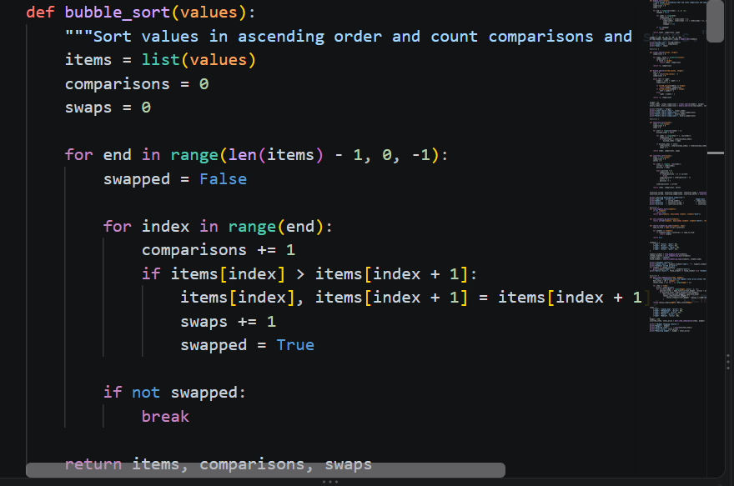
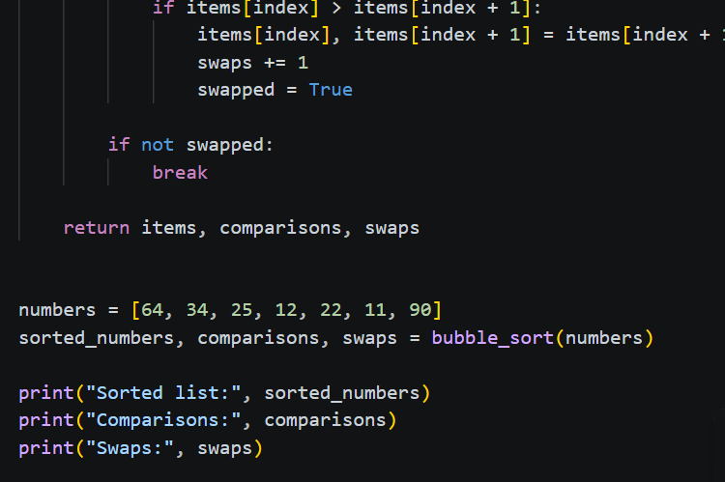

4.OUTPUT
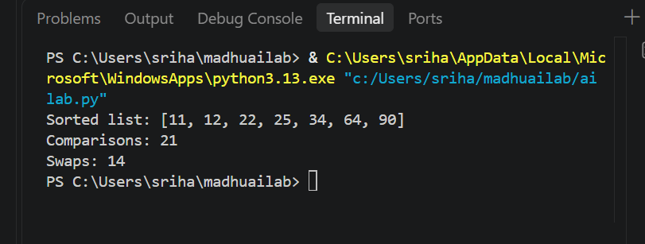
5.Observation
Bubble Sort arranged the list in ascending order: `[11, 12, 22, 25, 34, 64, 90]`.
For the given input, it made **21 comparisons** and **14 swaps**. The algorithm has a time complexity of $O(n^2)$ in the average and worst cases.

2.Question
Q2 – Linear Search vs Binary Search
Problem / Starter Code:
numbers = [5, 12, 18, 23, 31, 45, 56, 72, 89]
target = 45

# TODO:
# Implement Linear Search.
# Implement Binary Search.
# Compare the number of comparisons.
Student Tasks:
• Implement Linear Search and Binary Search.
• Use AI to explain why Binary Search requires sorted data.
• Count comparisons for both algorithms.
• Test first, middle, last and absent elements.
• Compare the results and explain suitable use cases.
• Use AI to suggest a valid optimisation.

2.Prompt
Write Python code for Linear Search and Binary Search using:
[5, 12, 18, 23, 31, 45, 56, 72, 89]
Test 5, 31, 89, and 100. Count comparisons and print results. Add simple comments.
3.Code
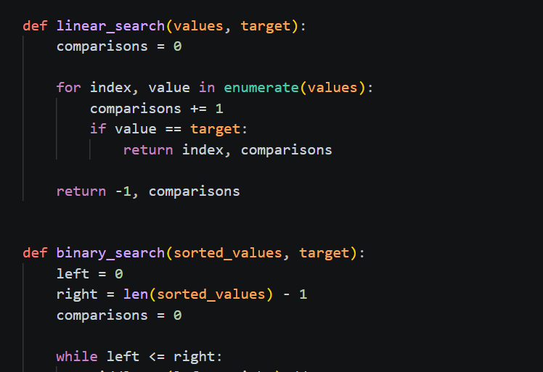

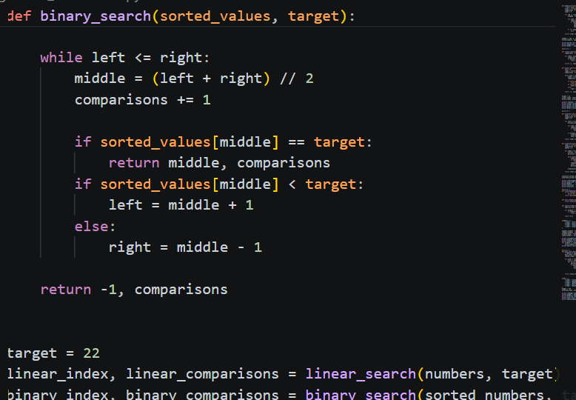

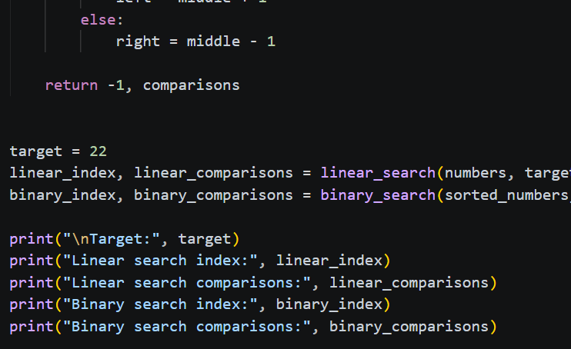

4.OUTPUT

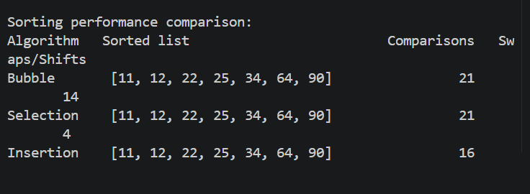

5. OBSERVATION
Linear Search checks one by one: O(n).
Binary Search checks the middle: O(log n).
Binary Search needs sorted data and usually uses fewer comparisons.

3. QUESTION
Q3 – Compare Sorting Algorithms
Problem / Starter Code:
data = [45, 12, 78, 34, 23, 89, 5, 67, 10, 56]

# TODO:
# Sort using Bubble Sort, Selection Sort and Insertion Sort.
# Compare their performance.
Student Tasks:
• Implement all three sorting algorithms.
• Use the same input for each algorithm.
• Count comparisons and swaps/shifts.
• Use AI to explain strengths and weaknesses.
• Ask AI which algorithm suits nearly sorted data.
• Compare experimental results with theoretical complexity.

2 . PROMPT
Write simple Python code for Bubble Sort, Selection Sort, and Insertion Sort using the given data. Count comparisons and swaps/shifts. Print sorted data and results for all three algorithms.

3. CODE
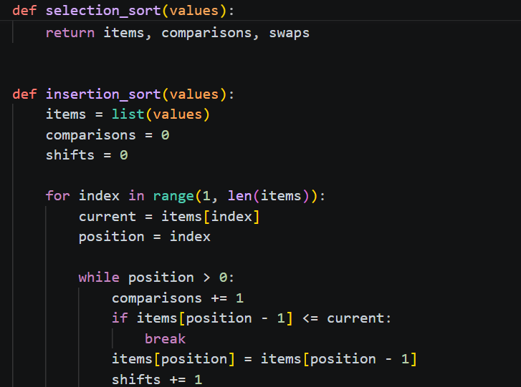

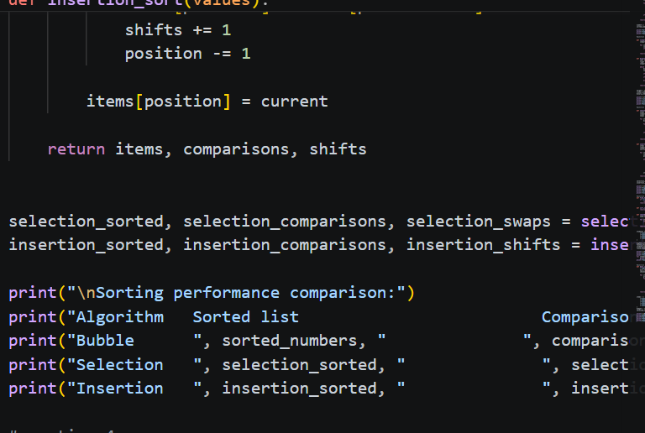

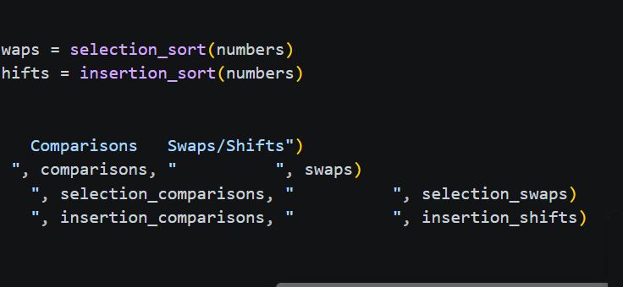

4. OUTPUT

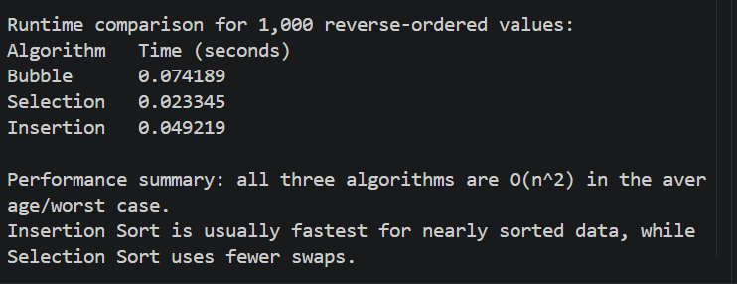

5. OBSERVATION
All three algorithms sorted the data correctly.
Bubble, Selection, and Insertion Sort have O(n²) average/worst-case complexity.
Insertion Sort is best for nearly sorted data.

- QUESTION

Q4 – Optimising a Student Search and Sort Program
Problem / Starter Code:
students = [
("Arun", 82),
("Bala", 65),
("Chitra", 91),
("Divya", 74),
("Esha", 88)
]

# TODO:
# Find the highest mark.
# Sort students by mark.
# Search for a student by name.
# Improve the solution using AI.
Student Tasks:
• Write functions for highest mark, sorting and name search.
• Create a straightforward solution first.
• Use AI to identify unnecessary operations.
• Ask AI for a more efficient approach.
• Implement only suggestions you understand.
• Compare original and improved time complexity.

- PROMPT
Write simple Python code using the given student list.
Do these tasks:
- Find the highest mark.
- Sort students by marks.
- Search for a student by name.
- Show a simple solution first.
- Suggest a more efficient solution.
- Compare the time complexity of both solutions.

- CODE

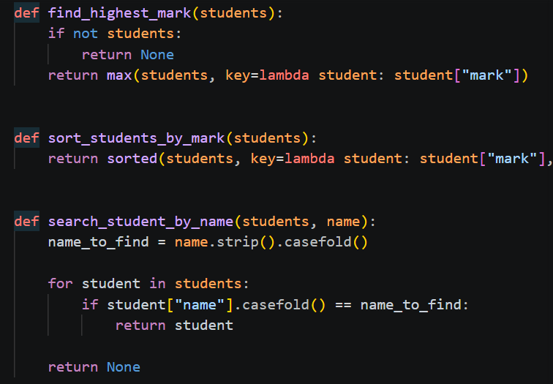

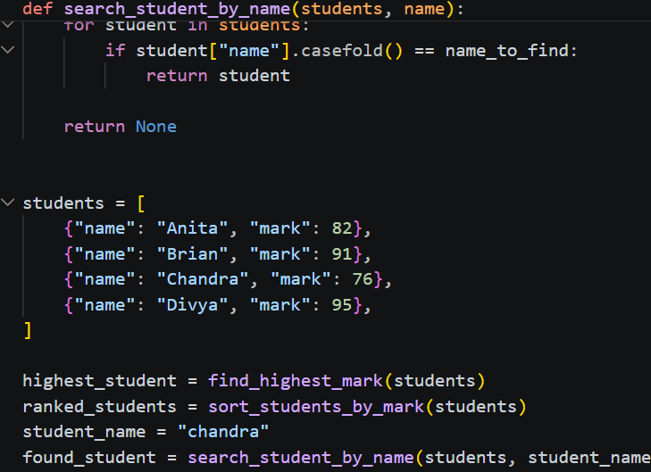

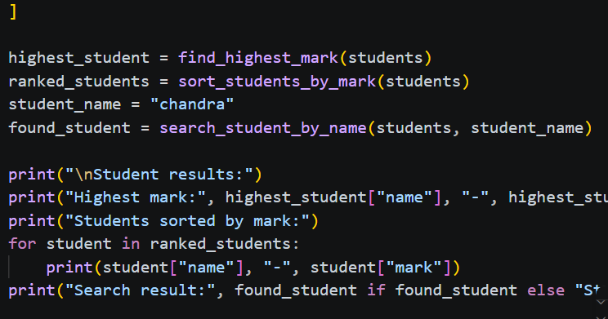

- OUTPUT
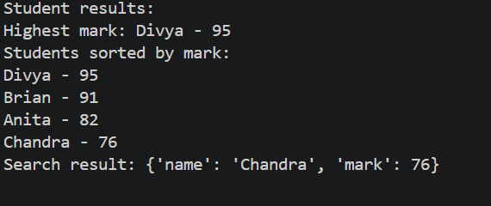

- OBSERVATION
The original solution uses simple loops and sorting.
The improved solution avoids unnecessary operations and uses efficient searching where possible.
Finding the highest mark takes O(n).
Sorting takes O(n log n).
Name search using a list takes O(n).
Using a dictionary for name search can reduce searching to about O(1) average time.

1.QUESTION
Q5 – Optimisation Challenge: Best Combination
Problem / Starter Code:
items = [
("Laptop", 60000),
("Phone", 30000),
("Tablet", 20000),
("Watch", 10000),
("Headphones", 5000)
]

budget = 50000

# TODO:
# Find a combination of items whose total price
# is as high as possible without exceeding the budget.
Student Tasks:
• Design a solution to maximise total value without exceeding the budget.
• Start with a simple approach and explain it.
• Use AI to compare Brute Force, Greedy and Dynamic Programming.
• Determine which approach guarantees an optimal solution for this formulation.
• Implement the selected solution.
• Test at least three budgets.
• Explain time and space complexity and possible optimisation for larger inputs.

2. PROMPT

Write simple Python code to find the best combination of items within a budget.
Use:
items = [("Laptop", 60000), ("Phone", 30000), ("Tablet", 20000), ("Watch", 10000), ("Headphones", 5000)]
Test budgets: 50000, 40000, and 25000.
Compare Brute Force, Greedy, and Dynamic Programming. Explain which guarantees the optimal answer. Implement the best method and show total price, selected items, time complexity, and space complexity.

3. CODE

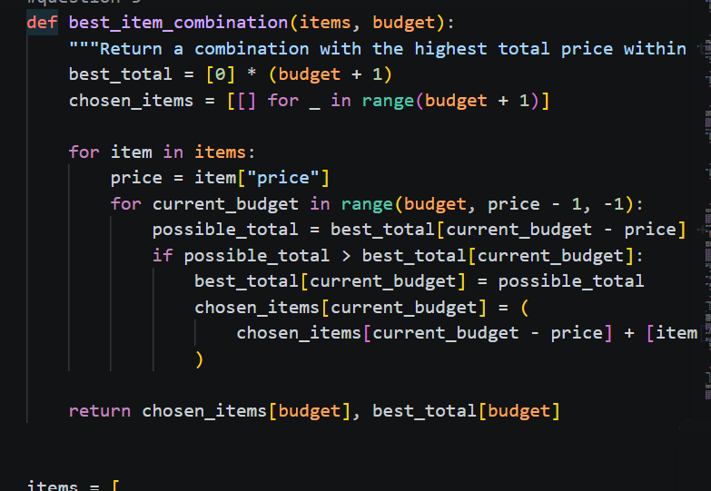

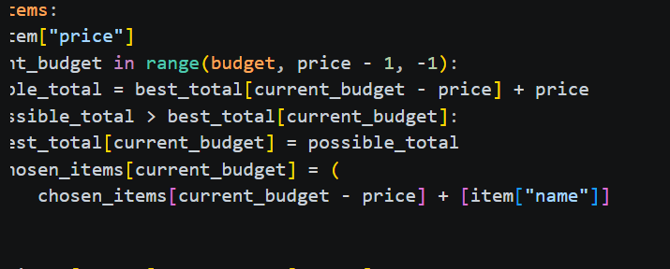
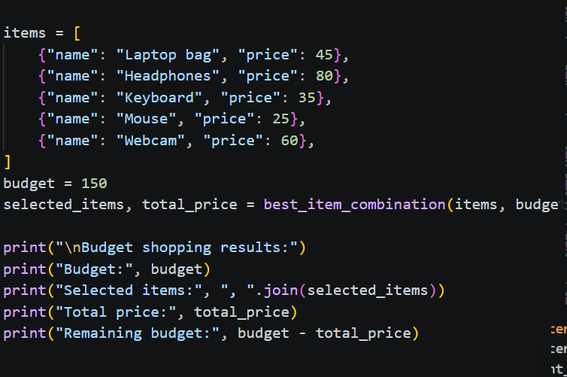

4. OUTPUT

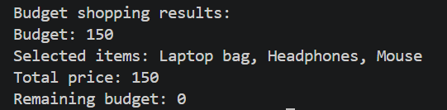

- OBSERVATION
Brute Force checks all combinations and guarantees the optimal solution.
Greedy is faster but does not always guarantee the best combination.
Dynamic Programming also guarantees the optimal solution for this 0/1 problem.
Brute Force: O(2ⁿ)
Dynamic Programming: O(n × budget)
For larger inputs, Dynamic Programming is more efficient than Brute Force.

